- Find the mean of: 12, 15, 18, 20, 25
Mean : 12+15+18+20+25 = 90/5 : 18
Mean = 18

- Calculate the median of: 7, 10, 15, 20, 25, 30
Numbers : 7,10,15,20,25,30
Even count numbers = average of middle two :
15+20 /2 = 17.5
Median = 17.5

- Find the mode of: 3, 7, 7, 10, 12, 7, 15
Most Frequent value = 7

- Compute the range of: 45, 60, 72, 30, 90
90 – 30 = 60
- Find Q1, Q2, Q3 for: 5, 10, 15, 20, 25, 30, 35
Numbers = 5,10,15,20,25,35
Q2 = 20(median)
Q1 = 10
Q3 = 30
- Calculate the Interquartile Range (IQR) for: 8, 12, 15, 20, 22, 30, 35
Numbers : 8,12,15,20,30,35
Q1 = 12
Q3 = 30
IQR = 30 – 12 = 18
- Find quartiles for grouped data:
Class intervals: 0–10, 10–20, 20–30
Frequencies: 5, 9, 6
Numbers : 0-10,10-20,20-30
Frequency : 5,9,6 = 20
Q1 = 10
Q2 = 16.7
Q3 = 23.3

- Find the variance of: 4, 8, 6, 5, 3
Numbers = 4,8,6,5,3
Mean = 5.2
Variance = -1.2+2.8+0.8+0.2+-2.2 /2 = 2.96

- Calculate the standard deviation of: 10, 12, 14, 16, 18
Numbers = 10,12,14,16,18
Mean = 14
Variance = 8
Standard deviation = 8 : 2.83

`10. Calculate the standard deviation of: 10, 12, 14, 16, 18
μ = (2+4+6+8+10)/5 = 6
(x− μ)²
= 16, 4, 0, 4, 16 → Sum = 40
Variance = 40/5 = 8 Standard deviation σ = √8 ≈ 2.8
- Compute mean and standard deviation of: 2, 4, 6, 8, 10
Given data: 2, 4, 6, 8, 10
Mean (x̄) = (2 + 4 + 6 + 8 + 10) / 5
= 30 / 5
= 6
(x - x̄)² = 16 + 4 + 0 + 4 + 16 = 40
Variance = 40 / 5 = 8
Standard Deviation √8 ≈ 2.83

11. Find the covariance between:
X = (1, 2, 3), Y = (2, 4, 6)
Formula:
Cov(X,Y) = Σ[(x − x̄)(y − ȳ)] / n
X = (1,2,3), Y = (2,4,6)
x̄ = 2, ȳ = 4
Sum = 4
Cov = 4/3 = 1.33

12. Calculate the correlation coefficient for:
X = (2, 4, 6), Y = (3, 6, 9) = +1

- Determine if correlation is positive or negative:
X = (5, 10, 15), Y = (30, 20, 10)
= negative

14. Find mean, median, and mode of: 11, 13, 13, 17, 19, 21
Mean = 15.67
Median = 15
Mode = 13

15. Calculate range, variance, and standard deviation of: 5, 10, 15, 20
Mean
= 50/4 = 12.5
(x−μ)² → 56.25, 6.25, 6.25, 56.25
Sum = 125
Variance
= 125/4 = 31.25
Standard deviation
= √31.25 ≈ 5.59
Lower half: 5, 10 →
Q1 = (5 + 10)/2 = 7.5
Upper half: 15, 20 →
Q3 = (15 + 20)/2 = 17.5
Calculate IQR
IQR = 17.5 − 7.5 = 10

16. Find IQR and identify outliers for: 2, 5, 7, 8, 10, 15, 50
Q2 = 8
Lower half → 2,5,7 → Q1 = 5
Upper half → 10,15,50 → Q3 = 15
IQR = 15 − 5 = 10
Lower = Q1 − 1.5×IQR = 5 − 15 = -10
Upper = Q3 + 1.5×IQR = 15 + 15 = 30
50 > 30 → Outlier
IQR = 10
Outlier = 50

17. Draw a bar graph for student marks: 50, 60, 70, 80, 90
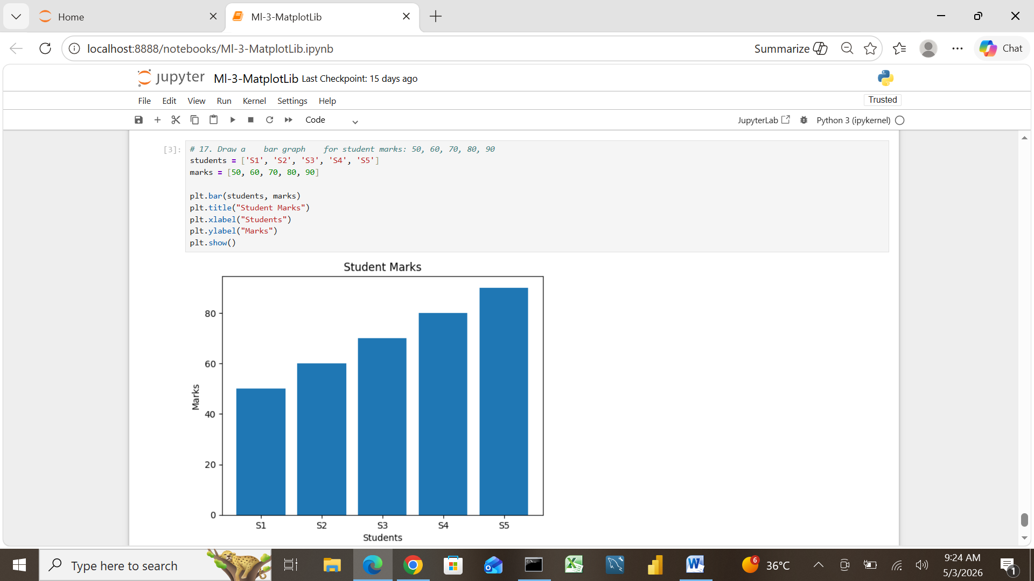

18. Represent given data using a pie chart :
A = 20, B = 30, C = 50
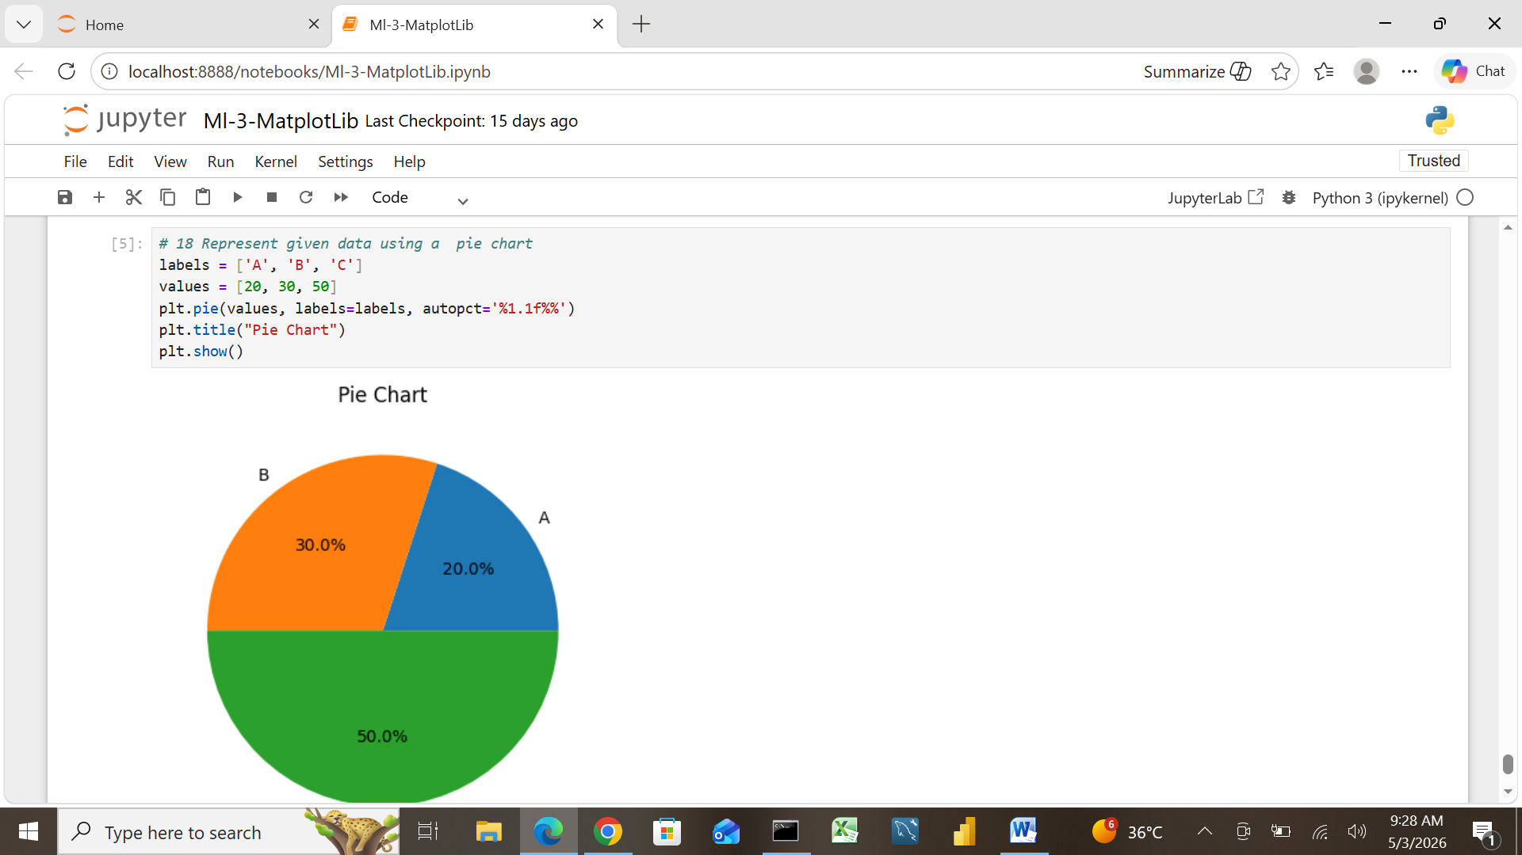

19. Plot a line graph showing sales over 5 days: 100, 120, 140, 130, 150
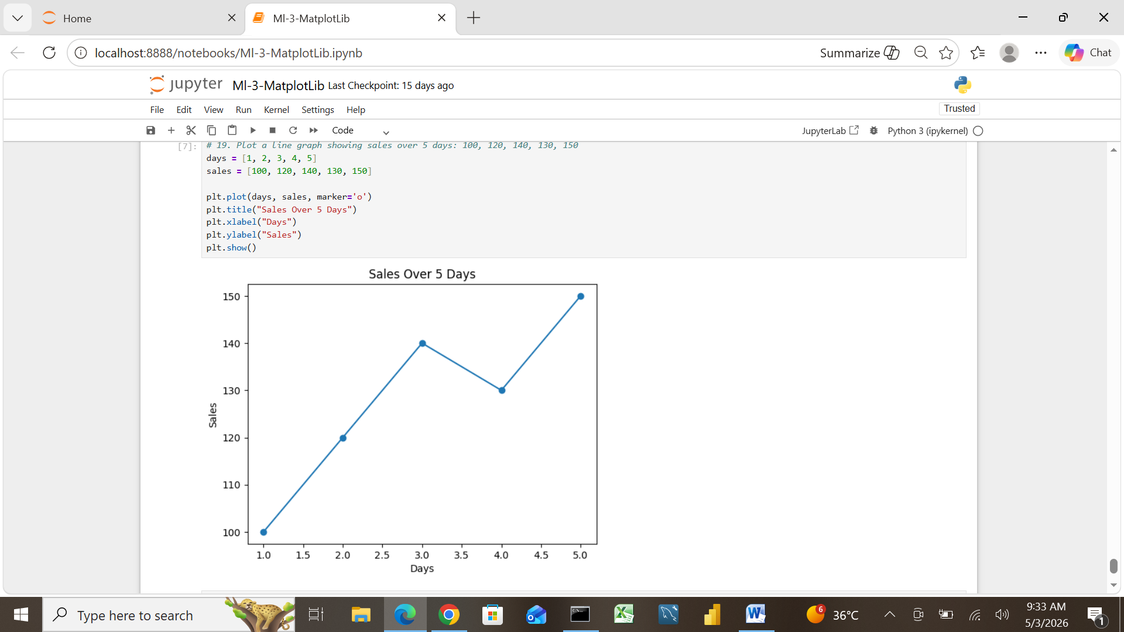
20. Create a histogram for grouped data:
Class: 0–10, 10–20, 20–30 Frequency: 4, 6, 5
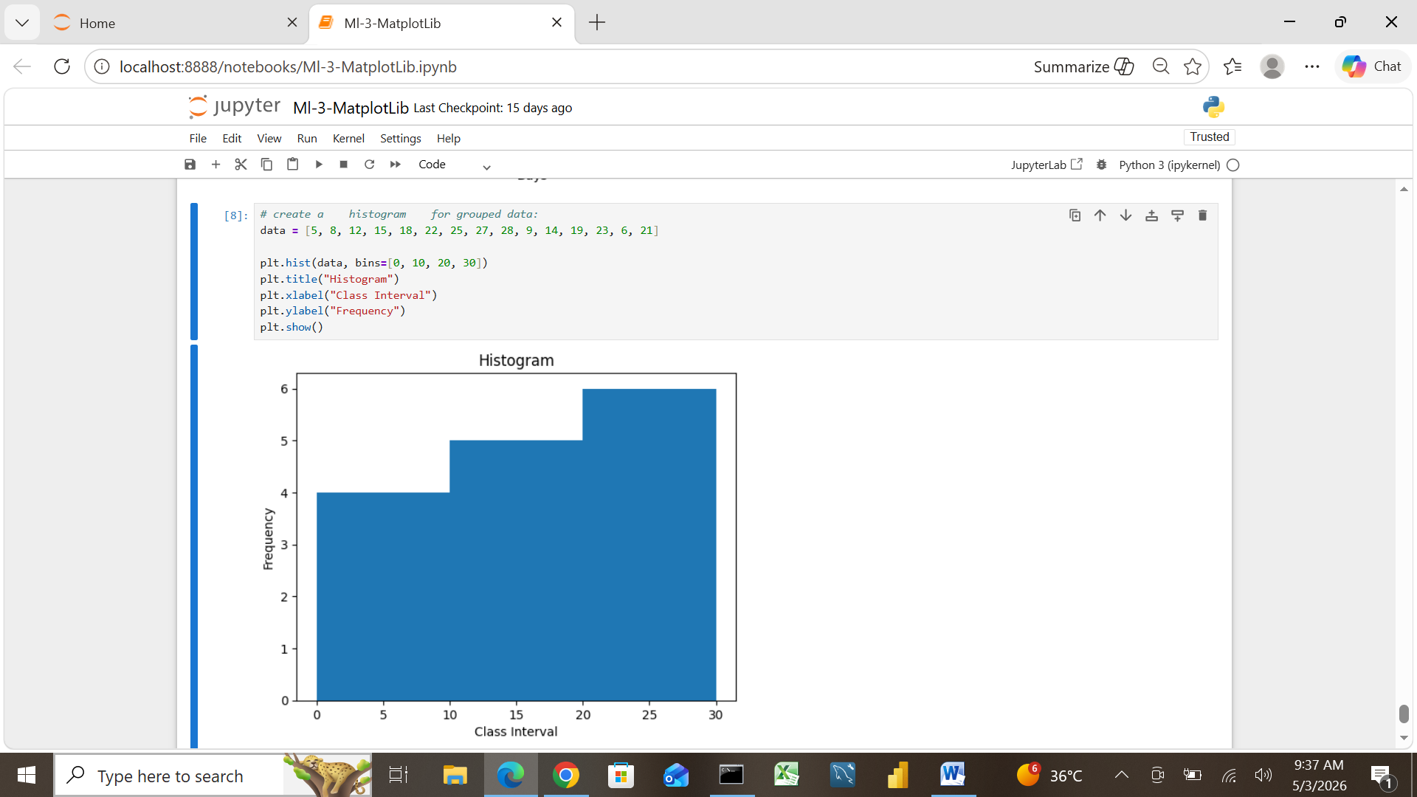

Applications
1. A teacher wants to evaluate class performance. Which measure ( mean, median, or mode is most suitable and why?
Measure : Mean
Reason: it shows the average marks of the whole class.

2. A company analyzes employee salaries where a few salaries are extremely high. Which measure of central tendency should be used?
Measure : median
Reason : it is not affected by very high or low salaries

3. A cricket analyst studies consistency of a player. Should they use standard deviation or mean ? Explain.
Measure : Standard deviation
Reason : it is shows how consistent the player is .

4. In a stock market dataset, how does correlation help in decision-making between two stocks?
Correlation – it shows relation between two stocks

5. A hospital tracks patient ages. How can histograms help in understanding the distribution?
Histogram : it shows age distribution clearly
6. A marketing team compares sales in different regions. Which graph ( bar or pie ) is better and why?
Reason : Bar Graph it is compare different regions easily

7. A dataset has extreme values. How does IQR help in detecting outliers ?
IQR : Interquartile range
Reason : it is help to find extreme values
Q1 : minimum value
Q3 : maximum value
Outlier : minimum and maximum values of in dataset

8. A researcher studies relationship between study hours and marks. Which method ( scatter plot or correlation ) is useful?

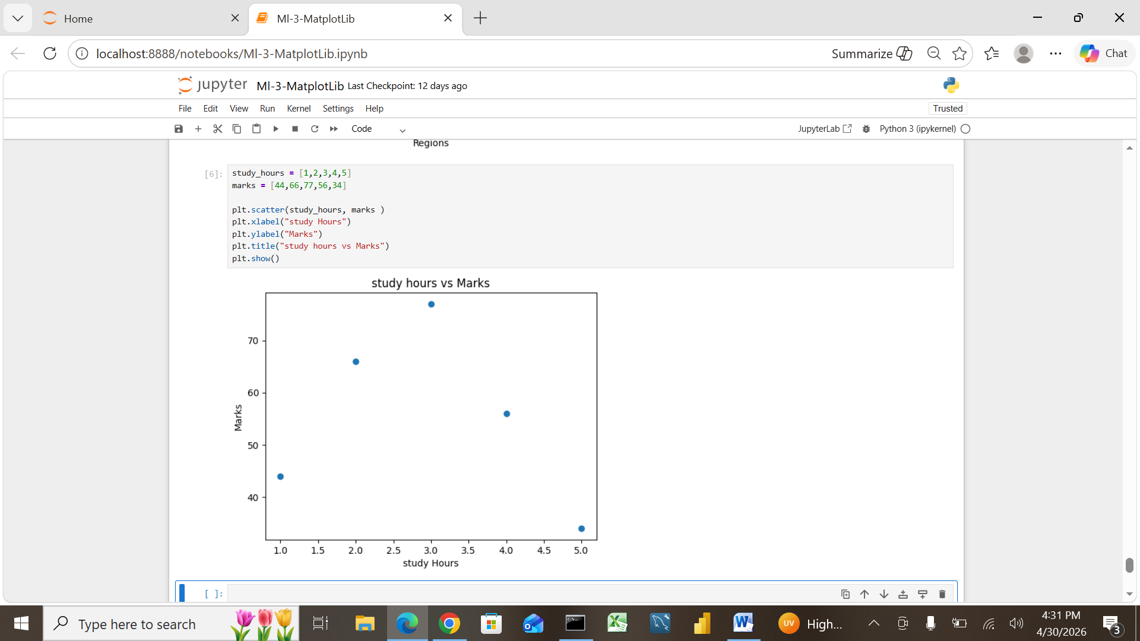
Scatter plot : scatter plot shows the relationship visually
Shows correlation strength
9. A business wants to see trends over time. Which graph ( line graph ) is most appropriate and why?
Line Graph : it shows changes and trends over time clearly
Why : it reason change trends over time
Because a line graph shows changes over time

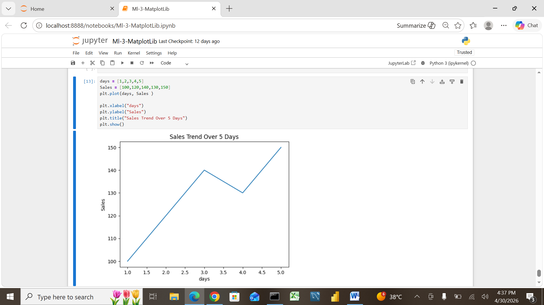

10. In machine learning preprocessing, why is standard deviation important for normalization/scaling ?
Standard deviation to normalization data so that all feature are on the same scal
Standard deviation helps make data balanced and comparable for machine learning.
Scaling makes data fair and balanced for machine learning models.

